When the user enters valid entries into the entry box.

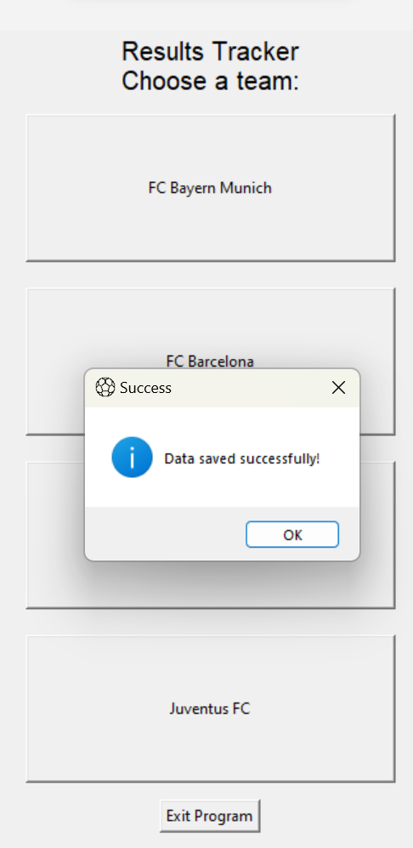

When the user enters invalid entries in the entry boxes.

